**Practical 5 goals:**

* Importing data

* Using help

**Importing data:**

We have seen that one way to import a data set is using ‘read.csv’.

This is for comma-delimited files. The more general command is ‘read.table’. You can specify numerous file types and other delimiters, and import data from formats that come from other statistics packages- but we won’t try much of that in this course.

Q1: Look at help(read.csv) to see the more general read.table command.

RStudio provides another easy way to get data.

They have an ‘import’ command which allows you to browse for the dataset you want to import. It is located in the ‘environment/history/connections’ window.

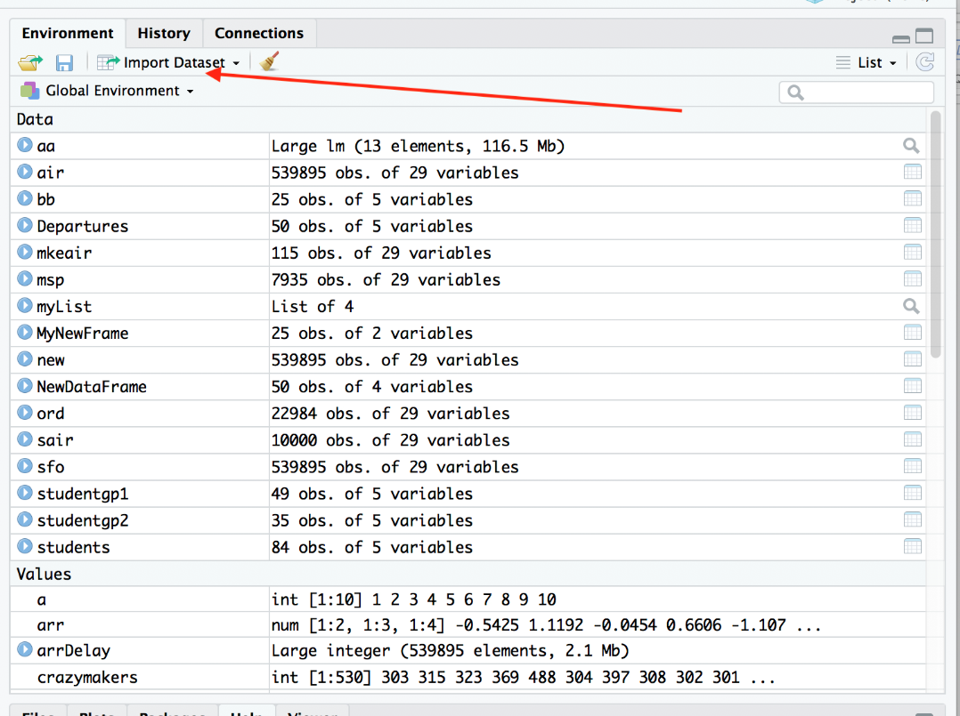

Q2: Use the import dataset tab to load the dataset ‘air’ as follows:

* First of all, delete the existing ‘air’ dataset using rm()
* Now type ls() and be sure it is gone.
* Now click on import dataset
* Choose text(base)
* Navigate to the correct directory
* Review the options- be sure the separator is ‘comma’. Make a mental note of the other options for future use.
* Choose ‘import’
* Use head() to see that the dataset is loaded.

For this question show all commands, and outputs if there are any. To show the dataset use the head() command and print the first 4 rows.

**Using Help**

There are many ways in R to get help. This is good- because it can be almost impossible to figure out how to do most things unless someone shows you or gives you the function name. Function names like ‘plot()’ or ‘table()’ are pretty easy to guess- but something like ‘lm()’ (for linear regression) aren’t so obvious.

When you need help:

At the program's command prompt you can use any of the following: (note: ‘foo’ is commonly used in programming to represent some unknown problem…)

* help(foo) # help about function foo
* ?foo # same thing
* Use the search bar from the ‘help’ tab of the viewer window.
* apropos("foo") # list all functions containing string foo
* example(foo) # show an example of function foo
* search for foo in help manuals and RSiteSearch("foo")

Q3:

* Get help on the command mean using help().
* Get an example of mean() using example() (Also note that if you use help() there will always be examples at the end of the file.
* Note that all R examples are completely independent- you can copy any example from a help file and paste it into R and it will run.

Another way to get help is to type something into Google.

Q4: Type ‘How to add text to a plot in R’ into Google now. Look at a webpage that seems to answer the question, and give the URL (address) of the page.

Sample Datasets

R comes with a number of sample datasets that you can experiment with. Type data( ) to see the available datasets. The results will depend on which packages you have loaded. Type help(datasetname) for details on a sample dataset.

Q5: Type data() to see all available datasets in R. You don’t need to show all the datasets- just show the first 5 using cut and paste on the output. Type help(iris) to see help on the iris dataset.